MGT 105 Notes
Sep/30/2019
- We will always be talking about you
- We are all going to brand management after graduation
- All email start with an email, with mgt 105 on it
- Adwave
  - Monday (9/30) 8:00P.M. WFN108
  - Wednesday (10/2) 8:00 P.M. WFN 108
  - Client is adobe system
  - 160 students and take 35
  - They teach in adwave
- Ucsddebate.weebly.com/
- English is the world business language
- The world of business doesn’t not reward the shy and quiet
- How to get an A
  - Read the syllabus carefully
  - Come to class
    - If u don’t come to class, you can send him an email and for fully excuses
  - Participation
  - Take notes
    - Nothing is posted
  - Read the assigned reading
  - Invest the time into the paper
  - 2 rady lab
- What is product promotion
  - Two filters
    - He is teaching us how to promote product or filter
    - Personal brand of the career management
      - I am the product that I offer to the investment to start my company
  - Brand management is attempting to positively influence product, service, perceived by consumers and the society
- Well Fargo bank
  - Unrealistic sell culture
  - 2 million fake accounts
  - 53000 employee are fired
  - Well Fargo executive, and will walk away with 124 million after he escaped by retirement
  - They try to recapture to be a reliable financial institution
  - When you put goal that is unrealistic, some is pressured into cheating
    - Employees are gonna sue well Fargo for getting pressured to open account
    - People called them why they have a random credit card or bank transfer
- Brand management is extremely important, but the CEO of Well Fargo do not understand it.

Oct/1/2019
- What’s this
- Klennex was a makeup remover, for disposable makeup remover towel
- Kleenex is generic for facial tissue
- Barley with down syndrome
- Top two elements in ads, yellow lab and kid
- Inline skate, and roller blade is the brand name and become generic
- Video score board, and jumbo truck is the brand name and become generic
- C5h5NO2, and super glue is the brand name and become generic
- Artificial truf, exo truf and is the brand name and become generic
- Poly*** foam, and Styrofoam is the brand name and become generic
- Adhesive bandage, and Band-aid is the brand name and become generic
- When they want a head of marketing, u want ur name to be top of their head
- When people think of bankruptcy, Campbell want people to think of him
- They think of you to fulfill their need
- 3M company, Minnesota mining manufacturing company
  - They want to make a super glue
  - The glue spill on desk
    - The glue is slightly sticky and easy to peel off
- Branding is extremely powerful
- The Enterprise Spaceship from Startrek
  - Some people love it so much
  - A businessowner build it as it’s headquarter
- UCSD Branding
  - Teaching how to brand UCSD, like the color and the font
  - You need a consistent image of the brand
  - They wrote it in a book as asset
- People won’t forgive a big brand if they made a mistake (new coke), and a weak brand like gateway
- What is great brand
  - Focus
  - Experiential
- Great brands gave to be
  - Different
  - vigilant
  - relevant
- Starbuck branded their coffee strongly
  - And has their own language
  - Business of serving people not coffee
- Cola
  - 61% of its’ asset is its’ brand
  - Around 40% is for the other things like the syrup and the formula’
  - Original formula of coke has cocaine
- You have to be different for your brand
  - No body out there is you, except you
  - They are a lot of force and pressure around u try to make you become something indifferent
    - We threw our competitive advantage away
    - try to fit in but being yourself
- Branding allow cola to make you have emotion feeling toward it
- Good brand has personality
- Brand are owned by the people (customers)
- Brand is more than a logo, it is something intangible
  - Focus
  - Experiential
- High risk high reward, brand management
- Branding history
  - Before
    - There was a few brand, and easy brand choice
    - Clear USPS- unique selling proposition
    - People talk about the brand they like
    - WOM – word of mouth advertisement
      - 1 to 1
      - From trust people
      - And it is free
    - Massive media dominance
      - Internet still have not take over TV
    - Everyone is home to watch prime time Tv
    - 1965, average of 80% established with only three 60s tv-spots
      - ABC, CBC,NBC
    - Easy reach
      - How many eyeball can you reach
    - Anyone who say anything on the ads is believed and the sales is skyrocketed
    - Everyone is a fan of their brand
  - Today
    - internet
    - 65% of people feels continuously bombarded by ads
    - Too many brand
    - 600,000 brands, flop rate 70%
  - Audience is impossible to reach
  - Advertisement rejection
  - Brand become skeptic, because people can’t believe the message they give out
Week 2
Oct/7/2019
- Brand
  - Confidence, Passion, belonging, action
  - used to be a stamp
  - 2010 coca cola
    - Was valued at $70,452,000,000
  - Product, service, people, religion can be branded
  - When people use your Brand as a verb, that is remarkable
    - Google it
    - Hover the carpet
    - Skype your family
    - Photoshop that picture
  - Belonged to you right now
  - Used to be personal ownership
  - It is a mark, symbol
    - When Nike want to make a point, all they need to do is to show the symbol
  - All ads cost a lot of money to create the ads
    - Not having logo (mark) have to pay a lot to convey for their message
  - You can tell Disney apart from the words they use
  - Owning a sound
  - Store design
  - They are still owned but the emphasis is from them to you
  - Red = inspiration
  - Organization use their brands for “differentiation”
    - Clearly communicating what they stand for, they also leave a market for why they are different
  - Is an attempt that people who buy your product see you differently
    - Prove Your item is more superior
  - Brand name can be replace verbs, it can be noun
  - It has to be relevant
- There will always be people who want to get promote instead of you, the one who can differential yourself can earn the highest salary
- Marketing, and branding want to make something without a person personality to have a personality
- The higher value your personal brand is, the higher the salary.
- What is building a brand
  - Is not a logo
  - Not a company
  - Not your signage
  - It’s the total experience a customer has with your company
    - Personality
    - Positioning
    - Consistency
    - Promise
  - Simple
    - Be consistent with every customer touch point
  - Across your print web marketing collateral uniforms signage and merchandise
- What is a brand
  - Brand are everywhere around us
  - Represent the first thing that came to mind
  - Experience, style
  - Each time you meet the person, you have more mental notes of them
  - Every interaction define the brand
  - More than tag line,
  - Customer like it when the brand keep the promises
- Professor kevin lane keller
  - Value
    - What I give for what I get
    - Maximize it
- Top 15 best global brands ranking, brand value evolution
  - Nokia used to be paper producer
  - Gillette is gone
- Presidential campaign in south America
  - Brand is crisis Sandra bullock
- Cola war
  - Coca cola has an advantage of human taste bud
  - If u were a Pepsi drinker when you were young u will prefer coca cola when ur taste bud mature, because pepsi is too sweet
  - There are more people over 18 in the world
- Coke vs pepsi
  - Coke was invented to get over morphine addicent,
  - Made with wine and cocaine
  - Pepsi was also created for medical industry
    - Said it will boost energy
  - 41 g of sugar Pepsi, 38 gram of sugar coke
  - Market cap
    - Price of the single share * number of share outstanding
  - 2015 coke 43.7 billion revenue, pepsi
    - They are umbrella company
  - Pepsi owned 1200 product
- Cola war, top 5 pepsi vs coke commercial
  - God father film, pepsi coloa
  - Use coke as a step to buy pepsi
- The foreigner, jacky become the great actor

Oct/9/2019
- Competition between company can become a war
  - Coke vs pepsi,
    - Coke 28 gram, pepsi 41 grams
    - Loyalty programs
  - The cost of acquire a customer is 10 times more expensive than keeping the old one to come back to buy
  - Coke rewards program
  - YouTube, Twitter, Facebook, Instagram subscription
  - Some people say they can taste the different
  - The national look back
    - Coke used to be 5 cent per bottle
    - Coca cola got bored, so they want to wipe up pepsi
    - Research that pepsi is a little sweeter
    - Little more High fructose corn syrup added to coke
      - Everybody care, they thought people don’t care
      - “When things are working don’t fix it”Campbell
      - First word is coke, and second word is mommy
    - Coke was hyping the new coke, then bring back the old coke as coca cola classic
    - New coke violated every point of brand management
      - Destroyed the trust
      - No body thought that anyone will mess with the formula in the basement of the coke headquarter
      - New coke 90 days, pepsi sale skyrocket
        - Some people like the new coke so they keep it and have classic coke
        - People drinking the classic coke (coca cola classic) and think that it is not the right formula, even though it is exactly the same formula
    - 1985 lauched new coke
      - From the origin of 1886, coca cola remains the growth
      - Use to have power imaging capture consumer’s attention
      - The pepsi challenge is the successful campaine
      - The only thing coke didn’t try is to try to change the taste of the coke
        - People seem to like the new coke
        - Million of fund, and coke think that they know how to win over
        - New coke ranks with Edsel as a major blunder
          - Edsel is the brand that afford automobile
          - A lot of research to the automobile public to know what they want on the next generation of automobile
            - Research was not designed smartly
            - Half of the public hated the new car from Edsel
            - They realize that woman have huge purchase power of the car, they survey a lot of women
              - Women wish to switch gear easily
              - They didn’t make prototype and ask the market place
              - Women hated this car because every time they push the button, they broke the nail
        - Henry ford created the union
      - The pause that “gags” instead of “fresh”
      - Coke still market the curved bottle
      - Pepsi can dissolve the bacon
      - Coke is in liquid refreshing company
        - They buy the water company
      - Coke can recover from the mistake
- The consumer owned the brand
- Prof worked in Bank of America in the early 1970, the last 60 years that fixed trouble company
- Product promotion
- Top 10 Brand that failed
  - Lehman brothers
    - Largest bankruptcy in America
    - Was on the front end
    - Failure Caused by one middle guy who did a hedge fund oversea
  - Joseph beer
    - Campbell drink it, and he think it tasted like horse urine, so he don’t sip another beer at all until freshman year
    - Changed formula to save money
  - Atari
    - Crappy game
  - Circuit city
    - Inconvenience location, not targeting gamming, bad customer service
    - They had a lot of theft and by their inventory
    - Easier to get into airport than get into circuit city
    - Liquidated asset and sold all store
  - Blockbuster
    - They laughed at Netflix
  - Research in motion
    - Blackberry phone
      - Target professional
      - They did not focus on game, sales drop
  - Oldsmobile
    - General motor say bye to it
    - Oldsmobile and Pontiac are similar
    - The car campbell owned is in the museum
  - Kodak
    - Refuse to make digital camera, because they are afraid of film sales
  - Woolworth
    - World biggest department
      - Under the name foot locker
  - lane
- 10 Marketing failure
  - McDonald and the 1984 Olympic
  - US win, you win
    - USSR boycott
    - 144 medal, mcdonald gave out a lot of free stuff
  - Watchdog, facebook
    - Facebook
      - Is the largest nation in the world
      - If government don’t like facebook, they go to other country
  - Burger King
    - Wake up with the king, the figure is too creepy, it went viral but not increase sale
  - Snicker
    - Discrimination
  - Skittles
    - Touch the rainbow
    - Turn everything into skittles
    - Save company with cat video
  - Ayds diet candy
    - Help u lose weight, sound like aids that give u weight loss
  - Assimo
    - Help people with low mobility
    - Can’t walk upstair
  - Netflix
    - Shutting dvd
  - Ford edsel
    - Worked against them
    - Name sucks
    - Car is ugly
    - Mercury
  - New coke
- Create a brand to have personality to something that doesn’t has personality
- You owned a company, you owned ur self, u learn about ur own brand attribute
Week 3
Oct/14/2019
- Company that competes - Buiness
  - Energizer and duraceil
    - E is older
  - Budwiser and
  - Visa vs. Mastercard
    - Mastercard original name is wellfargo mastercharge
    - Visa (bank of America) original name is bankofamerica card
  - Hasthto and Mattel
  - Ford and GM
    - GM is able to remain after they filed bankruptcy
  - DC and marvel
    - Marvel blow DC away
    - Super man, iron man
    - Film and comic book industry
  - Adidas and pumas
    - Were originally 1 company owned by two brother
  - Microsoft and apple
    - Microsoft had competion with sony and google
    - Apple focus on
    - Microsoft focus on ubiquity
  - McDonald and Bugerking
    - All out battle
    - McDonald is on top
  - UPS vs fedex
  - Hertz bs axis
  - Comcast vs Verizon
  - Coke vs Pepsi
    - Coke is more successful company
- Branding, you have trivial
  - Element to competitive advantage
  - Brand is a beautiful beach
    - As we approach the beach, it is actually made out of different color of sand
      - Brand is similar
      - Brand is made up with thousand and hundred of thousand
- Color
  - Blue
    - Complement to orange
    - Brand attributes, Authority, truth, loyalty, trust, power, confidence, integrity, intelligence wisdom.
    - Ernst & young, citi, ford, AXA
    - Skype, GM, IBM, General electric
    - Jetblue, Pfizer, intel, Fairfield
    - KLM, Pillsbury, maytag, marshalls
    - Samsun, Walmart, capital one bank, nokia(was paper product)
    - Airline and pharmaceutical want blue to convey trust
    - Light blue - peace
    - Dark blue - stability, security,
    - Bluecross blue field
    - MBTA blue line – boston airline
    - Blue horizontal bands, IBM – put computer in the typewriter that can print back and forward
    - Candy brand use blue is m and m
    - Blue angels, indigo girls,
    - Honest solid respected intelligent confident
- Textbook (Chapter 1, brands and brand management)
  - Branding has art to it, it is not highly mathematical, it is not rocket science
  - No one singular answer to create a beautiful beach
  - You can find many combinations that are nice beaches
  - Product and services can be duplicated
  - You gotta give the product a different personality
- Learning objective
  - Define brand
    - Brand Element
      - Different components that identifies and differentiates a brand
        - Name, logo, symbol, package design, or other characteristics
        - Maple syrup has unique package design
      - Can be based on people, places, things, and abstract images

  - Brand equity
  - Brand versus product
    - Brand
      - Has dimensions that differentiate it in some way from other products designed to satisfy the same need
    - Product
      - Anything available in the market for use or consumption, that may satisfy a need or want
  - Through branding, organizations
    - Create perceived differences amongst products
    - Develop loyal customer franchise
    - Create value that can translate to financial profit

Oct 16, 2019
- Green
  - Attributes
    - Complentary to red
  - Vert, verde, growth, nature, rebirth, optimism, spring, fertility, relaxation, youth luck, healing, environment
  - Calming
  - Green room
  - Starbuck, green gaint, American express, the body shop
  - John deere, whole foods, TD, Perrier
  - Subway, extrude, Petrobras, lush, Green mountain, G, Aer Lingus
  - Land rover, waste management, fidelity, L.L.Bean
  - Sales of millions of bright green bottles filled with fresh-smelling hair care products
    - Frutics
  - French bank chose the color of American money for its logo
    - BNP
  - Rental car shuttle for the green bus
    - National
  - Relax, recycle. Revive, renew, fresh, alive, new, positive, organic green
- Chapter 1
- Why does brands matter?
  - Consumer
    - Encompass all types of customers, including induvial as well as organization
    - Function provided by brands to consumers
      - Identify the source or maker of the product
      - Simplify product decisions
      - Lower the search costs for products internally and externally
      - Helps set reasonable expectation about what consumer may not know about the brand
    - Signal product characteristics and attributes
      - On the basis of attributes products can be classified as
        - Search goods
          - Grocery product
          - Searching new brand
        - Experience goods
          - Amusement park
        - Credence goods
          - insurances
    - Reduce risks in product decision
      - These risks can be categorized as
        - Functional- thing may not work,
        - physical- thing may hurt u,
        - financial- u might over paid and u might lose money,
        - social psychological- don’t fulfill ur emotion need, and
        - time- u need to buy it again
  - Firms
    - Increase their worth
    - Brands provide valuable functions
      - Simplify product handling and tracing
      - Help organizing inventory and accounting records
      - Offer the firm legal protection for unique features or aspects of the product
      - Provide predictability and security of demand for the firm and creates barriers of entry for competitors
      - Provide a powerful means to secure competitive advantage
      - TM (trade mark) SM(Service mark)
  - Roles that brands play
  - Can anything be branded
    - Yes
    - Physical goods
      - Business-to-business products
      - High-tech products
    - Services
      - Role of branding with services
        - trust
      - Professional services
        - Accounting
        - LLP
    - Retailers and distributors
      - Target and walmart
    - Online products and services
      - Amazon, bestbuy-online competitor are eating their sales, price match anything you find online
    - People and organizations
      - The united way
  - Sports, arts, and entertainment
  - Geographic locations
  - Ideas and causes
    - Make America great again
- To sum up
  - Branding is universal and pervasive in different product categories
  - Applicable to both tangible and intangible offerings of an organization
  - Technological developments have impacted the way firms market their offerings
  - Organizations reap financial benefits from positive brand images
- Famous Big logo
  - Amazon – from A to Z
  - Baskin Robbins, 31 flavor
  - Fedex arrow moving forward
  - Tostitos
  - Hersey kiss
  - Sony, binary digit
  - Solidify ur brand
  - More memorable
  - Build trust
- Strong brands
  - Brands that have been market leaders in their categories for decades
  - Any brand is vulnerable and susceptible to poor brand management
- Factors responsible for branding Challenges
  - Savvy customers
  - Economic downturns
    - If ur brand can save u even when u cost a lot
  - Brand proliferation
    - Lot of brand try to get ur attention
  - Media transformation
    - 65% reach placing the ads back in the date
    - Today we market on the fishing channel
  - Increased competition
  - Increased costs
  - Greater accountability
- Brand Equity
  - Principles of branding and brand equity
    - Differences in outcomes arise from the “added value” endowed to a product
    - The added value can be created for a brand in many different ways
    - Brand equity provides a common denominator for interpreting marketing strategies and assessing the value of a brand
    - There are many different ways in which the value of a brand can be exploited to benefit the firm
  - Well known brand name
  - Brand equity is positive
  - We should use the same brand name, if the brand name is famous
- Kevin Lane Keller
  - You have define the competitive frame of reference
  - Different competitor will result on different position
  - POD point of different
    - Different brand association
  - POP point of parity
    - Similar to other brand
    - Peets and starbucks
  - Desirable
  - Deliverable
  - Differentiating
    - Fedex began the over night shipping race
    - Fundamental of marketing, better faster and cheaper
    - Largest plane in the world
    - Reliable overnight service, if it has to be delivered overnight
  - recognize ur vulnerability
  - role play ur competitor, how do they think of you
  - their intended point of difference mean ur point of pairity.
  - POD I am more energetic than other UCSD student
  - Brand mantra
  - Slogan is external
    - Nike- just do it
  - Rolex
    - Salience to resonance
    - For prestige
  - Rolex people buy it to show off
  - Timex inexpensive time piece, originally less than 2 dollars
    - In the 50’s, it is proven as a quality watch
    - Tag line is “it take s licking and keeps on ticking”
- Strategic brand management process
  - Identifying and developing brand plans
  - Designing and implementing brand marketing programs
  - Measuring and interpreting brand performance
  - Growing and sustaining brand equity
- Identifying and developing brand plans
  - Brand Positioning model
  - Brand resonance model
  - Brand value chain
- Designing and implementing brand marketing program
  - Choosing brand elements
  - Integrating the brand into marketing activities and supporting marketing program
  - Leveraging secondary associations
- Measuring and interpreting brand performance
  - To manage brands profitably, managers must implement a brand equity m
- Figure 1.12 – strategic brand management process
- Budweiser ad-puppy
  - Yellow lap puppy

Oct 21, 2019
- Orange
  - Complement to blue
  - Brand attributes
    - Communicate
    - Competition
    - Force
    - Success
    - Vitality
    - Productivity
    - Strength
    - Potency
    - Encouragement
    - Determination
    - Energy
  - Simply orange, orange TM, travel channel, new your knicks
  - ING bank
  - All scripts
  - Fanta
  - Nickelodeon
  - UBL
  - Crush
  - Glaxosmithkline
  - Gulf oil
  - Easy het
  - Harley-davidson
  - Firefox
  - Boss, e blogger, Georgia, Reese’s
  - Sunkist
  - At&t, the home depot, hooters
  - People in this country rank it highly,
    - France
  - Why do many cafeterias use the color orange abundantly
    - Because the color orange is know to stimulate appetite and therefore increase sales
  - What internationally known celebrity chef
    - Chef Mario Batali
  - What public art exhibit in new your central park featured over 7500 orange fabric panels
    - The Gates by chrstopher
  - Orange county
  - The orangeline
  - Determined
  - Vital
- Personal branding- five easy steps – Amanda Rose
  - Everything counts as your own brand
  - Values
    - Foundation for your brands
  - Attitude
    - Empty vs full
    - Fix it or REMOVE it
    - Easiest thing in the world to fix, because it is all internal
  - Passion
    - Do you want to be a CEO
    - Do what you love
  - Purpose
    - Plan your FUTURE!
    - You can’t get it wrong with your major
    - You don’t have to get it right upon graduation, you just need to get started
    - Campbell ran company from 7 different industry
      - COO CFO
    - As long as you turn ur leg and move forward you can’t get it wrong
  - Six words
    - 6 words that Describe yourself
      - Resilience
      - Trustworthy
      - Fun

    - These are the word that people think of you
  - You are born with unique selling proposition (USP)
    - Company can say about their brand that nobody else has
    - Nobody else can claim to be you
    - We lose USP because we want to fit it, but we should not do that
- If you want to stand out
  - You need something that set you apart
  - Craft your
  - Keep Business card consistent
    - Go meet with a lot of people
    - People will call you to get a job
    - Networking is a key tactic to be successful in the world
    - If you don’t have a businesscard
    - One of the easiest way to get contact is through business card
    - Vistaprint.com
    - Full name, school and when to graduate, and email
    - America flag go behind the card
      - Symbol of power
    - Pick a color
      - Red is power
      - Whiteshirt and red tie to win
    - Join organization in your field, you need to provide valuable connection
- Building a generic resume in this class, personal branding is all about differentiating yourself from everybody else
  - Never send ur generic resume to anywhere
  - You should customize your resume
  - Generic resume is a guide
  - Expensive envelope
- 4 principle of career distinction
  - What makes some people exceptional?
  - Stand out
    - Stand for something
  - Be your own boss
    - Proactively manage your career
  - Forget the ladder
    - When we seek the next ladder, we look at the resume
    - Manage your career everyday
  - Build your brand
    - People who are wildly successful
- How to not build your brand
  - Don’t be fake
    - Be genuine
    - Don’t be wishy-washy
      - Take a stand
    - don’t act before thinking
      - have a plan
    - don’t go for quantity
      - over quality
      - you use the right resource
    - avoid the fame
      - choose to become selectively famous
        - just for the people who need to see it
    - don’t run steam
      - slow and steady to win the race
    - don’t forget real world relationship
      - real world activity and bring it virtual
    - don’t go alone
      - bring in right resources
    - don’t it all about it
      - all about giving value
    - don’t forget to measure
- Chapter 2
  - Define customer- based brand equity
  - Outline the sources and outcome of customer based brand equity
  - Brand mantra
- Customer based brand equity
  - Approaches brand equity from the perspective of the consumer
  - Stresses that the power of a brand lies in what reside in the minds and hearts of customers
  - Differential effect that brand knowledge has on consumer response to the marketing of that brand
- Brand equity as a bridge
  - Brand as reflection of the past
  - Brand asa t
- To sum up
  - Consumers perception of the brand plays a key role in determining the worth of the brand
  - Brand equity offers guidance to interpret past marketing performance and design future marketing programs
  - Other factors that influence brand success and equity are
    - Employees, suppliers, and channel members
    - Media and government
- Brand knowledge
  - Key to create brand equity
    - creates the differential effect that drive
- Sources of brand equity
  - Brand awareness
  - Brand images
- Brand image
  - Strength of brand associations
    - More deeply a person thinks about product info
- To sum-up
  - To create brand equity, marketers should
    - Create fab
- Identifying and establishing
- Scope of positioning
  - Brand positioning
  - Image positioning
  - The methodology to differentiate your brand in the market and the consumer’s mind
  - The art and science of fitting the product or service to one or more segments of the broad market in such a way as to set it meaningfully apart from competitor
  - Awareness, benefits
  - socioeconomic
  - Demographic
  - Usage
  - Behaviors
  - Psychographic
  - Geographic
  - Attributes, quality, application, class, user, competition, symbols, life style
  - Positioning
    - based on size
    - based on shape
    - based on toughness and endurance
    - based on low price
      - Walmart, comfort inn & syutes, greyhound, budget
    - Based on high price
      - Rolex
    - Based on quality
      - IBM
    - Based on time of day
      - Kitkat
      - Tang
      - Kellogg’s
    - Based on substitution
      - Parkay
      - Coffee mate
    - Based on sex appeal
      - Calvin klein
    - Based on sex of consumer
      - Lave, irish spring, Marlboro
      - Timotel
      - Gillette sensor excel
    - Based on homosexuality
    - Based on age
    - Based on athletic approach
    - “we are the original” originality
      - Cocacola
    - Based on cultural symbol
    - Based on lifestyle
    - Brand is better than (competition) for (target) because it (buting
    - Lever’s BPS/APS Format
    - Searchers, traditional, undecideds, copers, dreamers
    - Pillsbury
      - Chase, careful cooks
      - Position in different way
    - Y&R’s 4 Cs
      - Hierarchy of need
    - Perceptual maps
      - Purchase price, amenities
    - Snack food gap map
Oct/23/2019
- What is the structure of the project, the chapter will be a outline
  - You can have any structure
- Table chart graph picture can be used, as long as you communicate with the TA
- ALA, MLA, he don’t care
- The easier you make the citation the easier she might grade you easier
- You can choose as much product as you want
- We can cite the textbook
- Create personal logo
- Purple
  - Complementary color yellow
  - Royalty, ambition, wealth competition mystery spirituality mysticism magic inspiration dignity luxury
  - Welch’s, new your university, Sofitel, stop&shop, yahoo, fedex, edinbrich
  - The championship, LSU, THAU, DreamWork., curves, los Angeles lakers, Hawaiian airline
  - Ally, Minnesota state, FedEX ground
  - Which recording artist has a real passion for the color purple
    - Prince
  - U.S. Fashion house has a high-end brand that uses the color purple,
    - Ralph lauren
  - Purple Heart Hall of Fame is located in
    - New York
  - Purple pill, prescription drug that controls acid reflux
    - Nexium
  - Why is the color purple often associated with wealth or royalty?
    - Purple dye was both hard to get and very expensive
  - Purple cow, heart, rain, cow, label
  - Magical powerful spirutal, loyal
- Brand positioning
  - Act of designing the company’s offer and image so that it occupies a distinct and valued place in the target customers’ minds
  - Finding the proper location in the minds of consumer or market segment
  - Allows consumers to think about a product or service the right perspective
- Positioning example
  - Competitive positioning
    - Its how to win
    - Brand loyalty
  - Why competitive positioning
    - Products are commodities
  - Johnson’s brand
    - Perceptions of Trust, high quality, memories, dependability
      - They know that talc is dangerous to women, the perception for johnson and johnson went out of the window
  - Products
  - Can be knocked off
- Positioning brand
  - Marketing mistake
    - Bad writing, bad action,
  - Your ads has to be so dazzingly and fun that your customer can’t turn away
  - All product info, but entertained
  - Reveal features
  - Take a hard look of your product, is your product revolutionary
  - Sometime humor can be dangerous, and people don’t know what the commercial is for
- Target
Market
  - Market segmentaion: divides the market into distinct groups of homogeneous consumers who have similar needs and consumer behavior
  - Involves identifying segmentation bases and criteria
    - Identifiability
    - Size
    - Acceibily
  - Segmentation bases
    - Behavior
    - Demographic
    - Psychographic
    - Geographic
  - B2B segmentation Bases
    - Nature of good
    - Buying condition
    - Demographic
- Hypothetical examples of funnel stages and transition
  - Aware
    - 95% awareness
    - Doesn’t mean people try it
  - Ever tried
  - Recent trail
  - Occasional use
  - Regular use
  - Most often use
- Nature of competition
  - Comparative analysis
  - Indirect competition
  - Multiple frames reference
- Points of parity and points of difference
- To sum up
  - Identify their target customers
  - Analyze the type of competition they might face in the identified market base
  - Identify product features and association that are different or similar
- Positioning guideline
- Brand position say how a brand can compete against a specified ser of competitor
- A good product postitioning should
  - Have a “foot in the present” and a “foot in the future”
  - Identify all relevant points-of-difference
- Brand Mantra
  - Hard to get to the positioning
  - Few way to do marketing right
    - Elevator speech, define a brand in 30 sec
  - Marketing research
    - What is going on
  - Mental map
    - ask consumer “what comes to mind when you think about V8?
    - The brand association are grouped into categories
    - Thought association that came up for the brand
  - Core brand values
    - Set of abstract conpepts or phrases that characterize the five to ten most important dimensions of the mental map of a brand
    - Relate to point-of paraity and points-of-difference
    - Mental
  - An articulation of the “heart and soul” of the the brand
  - Similar to brand essence or brand promise
  - Short three to five word phrases that capture
  - Designing the brand mantra
    - Brand fuction
      - Nature of product or service
      - Descriptive modifier
      - Emotional modifier
  - Designing the brand Mantra
  - Nokia phone
    - Don’t fight, switch
- Chapter 3: brand resonance and the brand value chain
  - Emphasize the customers
  - Goal of branding, resonance
  - Building a strong brand : four steps
    - Brand salience
      - Brand is relevant to us
    - Brand performance & brand imagery
    - Brand judgments & brand feeling
    - Brand resonance
      - No resonance unless you have performance
    - Stage of brand development
      - Identity
      - Meaning
      - Response
      - Relationship
    - Brand objective at each stage
      - Deep awareness
      - Pintos of parity
      - Positive
      - Loyalty
  - Resonance, buying the same product over and over again, you don’t get there until you get a strong brand
  - Customer-based Brand Equity Pyramid – picture
  - Brand Judgement
    - Quality
    - Credibility
    - Consideration
    - Superiority
  - Brand Resonance
    - Behavioral loyalty
    - Attitudinal attachment
  - Subdimensions of brand building block
  - Brand Value chain
- The brand value chain
  - Implications
    - Value creation begins with the marketing program investment
    - Value creation requires more than the initial marketing investment
    - Provides a detailed road map for tracking value creation that can make marketing research and intelligence efforts easier
  - Brand Value Chain
    - Marketing program investment
      - Product
      - Communication
      - Trade employee
      - Program quality (multiplier)
        - Distinctiveness
        - Relevance
        - Integrated
        - Value
        - excellence
    - Customer mind-set
      - Awareness
      - Association
      - Attitudes
      - Attachment
      - Activity
      - Marketplace condition (multiplier)
        - Competitive reaction
        - Channel support
        - Customer size and profile
    - Market performance
      - Price premiums
      - Price elasticities
      - Market share
      - Expansion success
      - Cost structure
      - Profitability
      - Investor sentiment (multiplier)
        - Market dynamics
        - Growth potential
        - Risk profile
        - Brand contribution
    - Shareholder value
      - Stock price
      - P/E ratio
      - Market capitalization

Oct28/2019
- Red
  - Complementary to green
  - Action passion determination courage desire energy potency lover power
  - Bank of America, Canon, Adobe, Harvard
  - United waves, Verizon, LG, Lilly
  - Circuit city, Netflix, Toyota, sharp
  - Virgin, nitendo, red bull, wella
  - Target, youtube, Marriott, red cross
  - Bending machines
    - Coca cola
  - Ends AIDS
    - Reds
  - Sports team
    - Boston red
  - Population that exceeds one billion has flag
    - China
  - Red herring
- Chapter 4 Brand elements to Build brand equity
  - Identify the different types of brand elements
  - List the general criteria for choosing brand elements
  - Key tactics
- Criteria for choosing brand
  - Memorable
  - Meaningful
  - Likable
  - Transferable
  - Adaptable
  - Protectable
    - Should throw your brand away if u can’t protect it
- Elements of the brands, choose a name
  - Brand elements
    - Brand name
    - Logo
    - Symbol
    - Character
    - Packaging
    - Color
    - Slogan
  - Questions
    - How well do the brand elements work together to provide an identity for the product or service?
    - What would customer think about the product if they saw the brand elements.
  - Choice criteria
    - Memorable
      - Easily recognized, recalled
    - Meaningful
      - Descriptive
      - Persuasive
    - Appealing
      - Fun and interesting
      - Aesthetically
      - Rich visual and verbal imagery
    - Protectable
      - Legally
        - Trademark, service mark
      - Competitively advantage
    - Adaptable
      - Flexible
      - Updateable
    - Transferable
      - Within and across product categories
      - Across geographical boundaries and cultures
  - Brand element choice
    - Each brand element [lay a different role in creating the overall perception
  - Advantages and disadvantages
    - Names
      - Pro – the anchor quick, easy to process and recall
      - Con- difficult to change globalization issues
    - Logos and symbols
      - Pro- attention getting can reinforce associations Global transfer
      - Con – Can get outdated can be ambiguous/misinterpreted
    - Characters
      - Pro- rich meaning attention-getting
      - Con- can get outdated global transfer
    - Slogans and Jingles
      - Pro- can be highly memorable catchy convey meaning
      - Con- difficult to translate musical taste differences
    - Packages
      - Pro – recognition convey info and meaning
      - Con – production issues channel concerns
  - Effect of Brand names
    - Consumers
      - Affects likelihood of purchase
    - Employees
      - Affects morale and productivity
    - Firm
      - Can limit opportunities – e.g. new products, new regions
    - Investors
      - Can cause subconscious judgment about the company’s merits/strength
  - Types of names
    - Descriptive
      - Names or describes the product/service
      - Lean cuisine
    - Metaphor
      - Represents attributes or symbolism
        - Infiniti
    - Surname
      - A person’s name
        - Ford Ralph Lauren
    - Arbitrary
      - Real words with no obvious brand association
      - Apple
      - Camel
    - Altered
      - Fictional words based on real worlds
        - Lucent
        - Spotify
    - Blended
      - Two words merged
      - Facebook
    - Invented
      - Nonsense words
      - Exxon
- Value of a good name
  - Virgin
  - Priceline.com
  - Google
- Names for new Start-ups
  - New businesses need their own websites and most recognizable URLs have already been taken
  - Solution: Invent Words
  - Mibblio, Kaggle, Shodogg an Zaarly
- Gap
  - The new logo kinda block the P
    - Not all capitalized
- Picking brand Names in China
  - Keep them in native language
  - Coca-Cola
  - 可口可乐 （tasty fun）
  - Reebok
    - Rui bu
      - Means quick steps
  - Colgate
    - Gao Lu jie
    - Reveling superior cleaning
  - Cadillac
    - Ka di la ke
    - Means nothing in Chinese
- Type of Brand elements
  - Brand names, URL, logos and symbols, characters, slogans, jingle, packaging
  - Red on cereal
- Brand Names
  - Captures the central theme or key associations of a product in a bery comnpact and economical fashion
  - Most difficult elemnt for marketers
- URL
- Logo and Symbols
- Characters
  - Special type of
- Slogans
- Jingle
- Packaging
- Critique of Brand Element Options
  - Brand elements
  - Memorability
  - Meaningfulness
  - Likability
  - Transferability
  - Adaptability
  - Protectability
- Chapter 5: Designing Marketing Programs to Build Brand Equity
- Marketing Fundamental terms
  - Marketing Mix
    - 4 P’s of marketing
      - Product
      - Place
      - Price
      - Promotion
  - Consumer-side Marketing
    - Customer value (product)
    - Cost to the customer (price)
    - Convenience for the buyer (place)
    - Communication (promotion)
  - Positioning & targeting
    - Postions is
      - Differentiation from competitor
      - Value proposition
        - What do you offer
      - Product dimensions
        - What do you do?
    - Target
      - Who the product is for
  - Value proposition
    - What is so good about you?
    - Product dimensions of toothpaste
  - Colgate Tooth pump
    - Children like to pumpout all of the toothpaste
  - Demographic segments
    - Gender
    - Age
    - Income
    - Education
    - Location
    - Marital status
    - Culture
  - Coke’s dimensions
  - Know your people
    - “if you nail positioning and targeting, the rest falls into place.” – phillip Kotler
  - A brand is
    - Is anty name, term, sign, smsbol, or design intended to differentiate the goods or services
  - Why brands?
    - Get consumers to indentify a number of desirable qualities and traits with your specific product
  - Brand Names
    - Harley is the best brand name
  - Brand value
    - Ad measure by antenna balls, mickey mouse ball cost more 3.95
    - Jack in the box ball is only .99
  - Market share
    - How big is your piece of the pie?
  - Terminology Recap:
    - Marketing Mix
    - 4 P’s and 4 C’s
- Chapter 5
  - Identify some of the new perspectives and developments in marketing
  - Describe how marketers enhance produce experience
  - New approaches embraced by marketers
    - Rapid technological developments
    - Greater customer empowerment
    - Fragmentation of traditional media
    - Growth of interactive and mobile marketing options
    - Channel transformation and disintermediation
    - Increased competition and industry convergence
    - Globalization and growth of developing markets
    - Heightened environmental, community, and social concerns
    - Serve economic recession
  - The new capabilities of the new economy
    - Consumer
  - Integrating marketing
    - Personalizing marketing
    - Reconciling the different marketing approaches
  - Personalizing marketing
    - Experiential marketing
    - Relationship marketing
  - Relationship marketing
    - Mass customization
    - One-to-tone marketing
    - Permission marketing
      - Opt 1 or opt out
  - Aftermarketing
    - User Manuals
    - Customer service program
    - Loyalty programs
- What is customer relation
  - Ragu
    - Show pasta, become childhood of the child
    - Pasta sauce is all about motherhood
  - Emotional marketing

Oct/30/2019
- Yellow
  - Complementary to
  - Energy sunshine joy warmth happiness caution warning vision intellect creativity light
  - Good year, kodak, powerbar, Pennzoil
  - Hallmark, ikea, dhl, national geographic
  - Interflora, Ferrari, bestbuy, shell
  - Comfortinn, Chevrolet, cat, sprint, VR, yellow pages, gunoco
  - Yello cab,submarine, tail, brick road, jacket.
  - New York city is often associated with yellow thanks to over 12,000 of these

  - What company produces the citrus flavored beverage Mello Yello
    - Coca cola
  - 3 fast food chains
    - Burger king, in and out,
  - Ocean does the yellow sea flow?
    - The pacific ocean
  - Warm
- 60 multiple choice question and true and false
  - The only bad question is the one you are not gonna ask
  - Green scantron
  - Put your name on the scantron
  - Number 2 pencil
- Learning objectives
  - Describe some of the changes in the new media environment
  - Outline the major marketing communication options
  - Describe some of the key tactical issues in evaluation different communication options
  - Identify the choice criteria in developing an integrated marketing communication program
  - Explain the rationale for mixing and matching communication options
- Marketing communication
  - Means by which firms attempt to inform, persuade and remind consumers about the brands they sell
    - Can contribute to brtand equity buy
- Media campaigns
  - Which medium should we use? For 2 million dollars budge
    - Medium - Channel to advertise
  - Media planning
    - Best way to advertise
  - Newpaper was the main channel
    - Decreased usage
    - Allow target based on geography and inexpensive
    - People are reading less
  - Magazine
    - Ability to target specialized market like martial art
    - Shared with reader
  - Radio advertisement
    - Frequent fun and engaging commercial
    - Different ads for different geographic
    - Cheap
  - Television
    - Provide figure
    - people fast forward the ads or ignore the ads
  - outdoor media
    - billboard
    - on bus
    - internet and alternate media
      - grow at a fast paste
      - Advergaming
        - Ads on video game
      - Vlog, cellphone
      - Advertainment
      - Stealth marketing
        - People don’t know they are looking at a ad
  - Evaluating media
    - Reach
      - Amount of conmers exposed
    - Frequenct
    - Cost per contact
      - Continuous
        - Constain based
      - Flighted
        - Once a month
      - Seasonal
        - Certain time of popularity
  - 6 contact points before you can make a sale
- The new media environment
  - Traditional ad media seem to lose their grip
  - Digital revolution has changed the way consumer learn and talk about brands
    - No GM use internet to sell, cause it doesn’t worl
  - Changing media landscape has forced marketers to reevaluate how they should vest communicate with consumers
  - Stan Freberg
- Challenges I designing brand building communication
  - Efficient and effective
  - Requite careful planning and creative knack
- Role of multiople communication
  - Advantages of multiple communications
    - Optimal utilization of monetary and other resources
    - Different communication options also may target different market segments
- Advertising
  - Any paid form of non-personal presentation and promotion of ideas, gppds, pr services by an identified sponsor
  - Powerful means of creating strong, favorable, and unique brand associations and eliciting positive judgments and feelings
  - Specific effects are difficult to quantify and predict
- Types of advertising media
  - Television, radio, print, direct response, place
- Events and experiences
- Brand amplifier
  - Efforts made to engage consumers and the public via word of mouth and public relations and publicity
  - Amplify the effecs created by other marketing activities through
    - Word of mouth
- Multimedia marketing
  - Attract people to your website
  - It’s getting easier and more cost effective
  - There’s a lot of people doing it wrong
  - Quality informative entertaining interesting
    - Attention and promotion by viewers and youtube
  - Good media has
    - Lighting, music, voice overs, stock photos, stock footage, equipment
  - Mass distribution
    - increase traffic
    - conver traffic
- developing integrated markeing communication program
- criteria for UMC program
  - coverage
  - contribution
  - commonality
  - complementarity
  - conformability
  - cost
- General marketing communication guideline
  - Be analytical
  - Be curious
  - Be single-minded
  - Be integrative
  - Be creative
  - Be observant
  - Be patient
  - Be realistic
- Chapter 7 leveraging secondary brand associations to build brand equity
  - 8 main way brand association
  - Conptuailzing the leveraging process
    - Create a new set of associations from the brand to the entity
    - Affect the existing brand association
  - Creation of new brand association
    - Secondary brand associations are most likely to affect evaluations of a new product when
      - Consumers lack either the motivation or the ability to judge product-related concerns
  - Effects on existing brand knowledge
    - Cognitive consistency
  - Company
    - Existing brands can be related to a corporate or family brand
    - A corporate or family brand can be a source of brand equity
    - Leveraging a corporate brand may or may not be useful
  - Country of origin or geographic location
    - Can be linked to the brand to generate secondary associations
    - Consumers choose brands originating in different countries based on
      - Their beliefs about the quality of certain types of products from certain countries
      - The image that these brands or products communicate
    - Can create strong points of difference
  - Channels of distribution
    - Retail stores can indirectly affect brad equity through an “image transfer” process
  - Co-branding
    - When two or more existing brands are combined into a joint product or are marketed
  - Ingredient branding
    - Creates brand equity for materials, components, or parts that are contained within other branded products
    - Branded ingredient
  - Licensing
    - Creates contractual arrangements whereby firms can use
      - Names’ logos and characters of other brands to market their own brand with fixed fee
  - Corporate trademark licensing
  - Celebrity endorsement

Week 6
Nov/06/2019
- Chapter 8 developing a brand equity measurement and management system
  - Almost everything in the business can be measured
  - New accountability in terms of ROMI
  - Two steps in conducting a brand audit
  - How to design conduct and interpret a tracking study
  - Implement a brand equity management system
- Is your brand helping or hurting your growth strategy?
  - You want to take your business to the next level
    - Ur brand is holding you back
    - Your brand make you look like everyone else
  - You need professional helo
  - Re Perez
    - CEO + founder
    - Fortune 500
    - Double or quadrible the revenue
  - 7 points brand audit
    - Components of the audit
      - Logo
      - Brand Color
        - 90% why we buy is based on color
      - Fonts and typography
      - Photos, videos, imagery
        - Picture thousand word
        - Videos a million words
      - Brand personality
      - Overall look and feel
      - Brand positioning
        - The most important
  - Inside out
    - Perception of self
  - Outside-in
    - How others perceived you
- Interbrand
  - Brand has the power to change the world
  - Strong brands drive improved business performance
    - Loyalty
  - Financial performance
    - Financial analysis
      - Profit
    - Role of brand
    - Brand strength
- BMW Brand Audit
  - BMW Group
    - BMW AURO
    - MOTOVRRADE
    - MINI
  - BMW AUTO
    - Form in 1916, motorcycle
    - Performance and style
    - Product differeciation stategy
    - Brand postioning
    - Brand Inventory
      - 9 ultra one
      - The logo
        - Efficient dynamic
        - Intraculture
    - Brand exploratory
      - Primary research
        - 61% male
        - 52.9% two car household
        - 39.2% 40-49 years old
        - 392 76k
        - 31.4 prestige, 23.5 luxury, price, performance
      - Secondary research
        - Forbes 11th
    - Recommendations
      - Product
        - Capture as much of the marketshare
      - Place: leverage their excellent online
      - Promotion: they should continue with their aggressive advertising cam[aisn and heavily
      - Price
- The new accountability
  - Conducting brand audits
  - Brand inventory
  - Brand exploratory
  - Brand positioning and the supporting marketing program
- Brand audit
  - Comprehensive examination of a brand to discover its sources of brand equity
  - Marketing audit
- Brand inventory
  - Comprehensive profile of how all the products and services of a company are marketed and branded
- Brand exploration
  - Preliminary activities
  - Interpreting qualitative research
    - quality
  - Conducting quantitative research
    - Reponses in the research
    - Use the terms that is used in the focus group and send it out to hundreds of people
  - Focus group
- Nilson can testify millions of people are watching
- Brand positingng and e the supporting marketing program
  - What customers currently believe about the brand
  - Value in the brand
- Designing Brand Tracking Studies
  - What to track
    - Product brand tracking
    - Corporate or family brand tracking
    - Global tracking
  - How to conduct tracking studies
    - Who to track
    - When and wher totrack
  - How to interpret tracking studies
    - Important benchmarks
    - Brand associations determining consumer behavior
- Brand Charter
  - Formalizes the company view of brand equity into a document
  - Provides relevant guidelines to marketing managers and key marketing partners
  - Should be updated on an annual basis to provide decision makers with a current brand profile
  - Everything has to be in writing
- To sum up
  - The company view of brand equity should be formalized into a document
  - The results of the tracking surveys should be assembled into a breand equity report
  - Senior management must be assigned to oversee brand equity within the organization
- Chapter 9: measuring sources of brand equity
  - Effective qualitative research techniques for tapping into consumer brand knowledge
  - Identify effective quantitative research techniques for measuring brand awareness, image, responses and relationships
  - Profile and contrast some popular brand equity models
  - Qualitative research techniques
    - Free associations
    - Projective techniques
    - Zaltman metaphor elicitation technique (ZMET)
    - Neural Research Method
    - Brand Personality and Value
    - Ethnographic and experiential methods
- Brand personality and balues
  - Brand personalility
  - Big 5
    - Sincerity
    - Excitement
    - Competence
- Quantitative research techniques
  - Brand awareness
  - Brand Image
  - Brand Responses
  - Brand relationship
  - People send the survey to direct mail
  - One element has to be included for direct mail
    - Writing instrument
    - Return envelope
    - Coupon
- Brand Awareness
  - Recognition
  - Recall
  - Corrections for guessing
  - Strategic implications
    - Yields insight into how brand knowledge is organized in memory
    - Identifies cues or reminders necessary for consumers to retrieve the brand from memory
- Perceptual map
- Brand Response
  - Purchase intentions
  - Likelihood to Recommend
- Brand relationships
  - Behavioral loyalty
  - Attitudinal attachment
  - Sense of community
  - Active engagement
- Qualitative research techniques
  - Free association
  - Adjective ratings and checklists
- Quantitative research techniques
  - Brand awareness
  - Direct and indirect measures of brand recognition

MGT 105 reading notes
Chapter 1
- Brand- is a “name, term, sign, symbol, or design, or a combination of them, intended to identify the good and services of one seller or group of sellers and to differentiate them from those of competition.
- Brand elements
- Product
  - Anything that we can offer to a market for attention, acquisition, use, or consumption that might satisfy a need or want
    - Core benefit level
      - Fundamental need or want that consumer satisfy by consuming the product or service
    - Generic product level
      - basic version of the product containing only those attributes or characteristics absolutely necessary for its functioning but with no distinguishing features.
    - Expected product level
      - Ser of attributes or characteristics that buyers normally expect and agree to when they purchase a product
    - Augmented product level
      - Additional product attributes, benefits, or related services that distinguish the product from competitors
    - Potential product level
      - All the augmentations and transformations that a proact might ultimately undergo in the future.
    - Consumers
      - Identification of source of product
      - Assignment of responsibility to product maker
      - Risk reducer
      - Search cost reducer
      - Promise, bond, or pact with maker of product
      - Symbolic device
      - Signal of quality
    - Manufacturers
      - Means of identification to simplify handling or tracing
      - Means of legally protecting unique features
      - Signal of quality level to satisfied customers
      - Mearns of endowing products with unique association
      - Source of competitive advantage
      - Source of financial returns
    - Search goods
      - like grocery produce, consumers can evaluate product attributes like sturdiness, size, color, style, design, weight, and ingredient composition by visual inspection
    - Experiences good
      - automobile tires, consumers cannot assess product attributes like durability, service quality, safety, and ease of handling or use so easily by inspection, and actual product trial and experience is necessary.
    - Credence goods
      - like insurance coverage, consumers may rarely learn product attributes.
  - Functional risk: The product does not perform up to expectations.
  - Physical risk
    - The product poses a threat to the physical well-being or health of the user or others.
  - Financial risk
    - The product is not worth the price paid.
  - Social risk
    - The product results in embarrassment from others.
  - Psychological risk
    - The product affects the mental well-being of the user.
  - Time risk
    - The failure of the product results in an opportunity cost of finding another satisfactory product.
  - Commodities
    - Product so basic that it cannot be physically differentiated from competitors in the minds of consumers.
  - Store brands
  - Private label
  - Strategic Brand Management process
    - Identifying and developing brand plans
    - Designing and implement brand marketing programs
    - Measuring and interpreting brand performance
    - Growing and sustaining brand equity
  - Brand element
    - Brand name, url, logos, symbols, characters, packaging, and slogans
  - Leveraging secondary associations
  - brand equity measurement system
    - is a set of research procedures designed to provide timely, accurate, and actionable information for marketers so that they can make the best possible tactical decisions in the short run and the best strategic decisions in the long run.
  - Brand audit
    - Comprehensive examination of a brand to assess its health, uncover its sources of equity, and suggest ways to improve and leverage that equity.
  - Brand tracking
    - collect information from consumers on a routine basis over time, typically through quantitative measures of brand performance on a number of key dimensions marketers can identify in the brand audit or other means
  - Brand equity management system
    - organizational processes designed to improve the understanding and use of the brand equity concept within a firm
  - brand portfolio
    - set of different brands that a particular firm offers for sale to buyers in a particular category
  - brand hierarchy
    - number and nature of common and distinctive brand components across the firm’s set of brands.

Chapter 2 customer based brand quality and brand positioning and
Chapter 3 Brand Resonance and the brand value Chain
- Customer-based brand equity
  - consumer has a high level of awareness and familiarity with the brand and holds some strong, favorable, and unique brand associations in memory.
- Brand awareness
  - Brand recognition
    - consumers’ ability to confirm prior exposure to the brand when given the brand as a cue.
  - Brand recall
    - is consumers’ ability to retrieve the brand from memory when given the product category, the needs fulfilled by the category, or a purchase or usage situation as a cue.
- Advantage od brand awareness
  - Consumer purchase motivation
  - Consumer purchase ability
- Establishing brand awareness
- Brand image
- Brand attributes
  - descriptive features that characterize a product or service
- Brand benefits
  - personal value and meaning that consumers attach to the product or service attributes.
- Brands positioning
- Market
  - set of all actual and potential buyers who have sufficient interest in, income for, and access to a product
- Market segmentation
  - divides the market into distinct groups of homogeneous consumers who have similar needs and consumer behavior, and who thus require similar marketing mixes.
- Segmentation bases
  - 1. The Sensory Segment: Seeking flavor and product appearance
  - 2. The Sociables: Seeking brightness of teeth
  - 3. The Worriers: Seeking decay prevention
  - 4. The Independent Segment: Seeking low price
- Citeria
  - Identifiability: Can we easily identify the segment?
  - Size: Is there adequate sales potential in the segment?
  - Accessibility: Are specialized distribution outlets and communication media available to reach the segment?
  - Responsiveness: How favorably will the segment respond to a tailored marketing program?
- Point of parity association
  - Category points-of-parity
    - represent necessary—but not necessarily sufficient—conditions for brand choice.
  - Competitive points-of-parity
    - associations designed to negate competitors’ points of-difference.
  - Correlational points-of-parity
    - are those potentially negative associations that arise from the existence of other, more positive associations for the brand
- Brand mantra
  - short, three- to five-word phrase that captures the irrefutable essence or spirit of the brand positioning.
- brand functions
  - the nature of the product or service or the type of experiences or benefits the brand provides.
- descriptive modifier
  - further clarifies its nature
- Brand performance
  - describes how well the product or service meets customers’ more functional needs.
- Primary ingredients and supplementary features.
- Product reliability, durability, and serviceability
  - Reliability
    - measures the consistency of performance over time and from purchase to purchase.
  - Durability
    - expected economic life of the product
  - serviceability
    - the ease of repairing the product if needed
- Service effectiveness, efficiency, and empathy.
  - Service effectiveness
    - how well the brand satisfies customers’ service requirements.
  - Service efficiency
    - the speed and responsiveness of service.
  - service empathy
    - extent to which service providers are seen as trusting, caring, and having the customer’s interests in mind.
- Brand Imagery
  - User profile
  - Purchase and usage situations
  - Personality and values
  - History, heritage, and experience
- Demographic
  - Gender
  - Age
  - Race
  - Income
- Brand Judgment
  - Customer’s personal opinions about and evaluations of the brand
- Brand Credibility
  - Extent to which customers see the brand as credible in terms of three dimensions
    - Perceived expertise
    - Trustworthiness
    - Likability
- Brand feeling
  - Customers’ emotional response and reactions to the brand
- Brand resonance
  - Customers feel that they are in sync with the brand
- Brand building implication
  - Salience
  - Performance
  - Imagery
  - Judgments
    - Quality
    - Credibility
    - consideration
  - Feelings
  - Resonance
    - Loyalty
    - Attachment
    - Community
    - Engagement
- Value stages
  - Marketing program investment
  - Program Quality Multiplier
    - Distinctiveness
    - Relevance
    - Integrated
      - Marketing program at one point in time and over time
    - Value
    - Excellence
  - Customer Mind-Set
    - Brand Awareness
      - Customers recall and recognize
    - Brand Associations
      - Strength, favorability, and uniqueness of perceived attributes and benefits for the brand
    - Brand Attitudes
      - Overall evaluations of the brand in terms of its quality and satisfaction it generates
    - Brand Attachment

    - Brand Activity
      - Customers use the brand, talk to others about the brand, seek out brand info, promotions, and events
  - Marketplace Conditions Multiplier
    - Competitive superiority:
      - How effective are the marketing investments of competing brands?
    - Channel and other intermediary support:
      - How much brand reinforcement and selling effort is being put forth by various marketing partners?
    - 3. Customer size and profile:
      - How many and what types of customers are attracted to the brand? Are they profitable?
    - Market Performance
    - Investor Sentiment Multiplier
      - Market Dynamics
        - Interest rates, investor sentiment, supply of capital
      - Growth potential
      - Risk profile
      - Brand contribution

Chapter 4 Choosing Brand Elements to Build Brand Equity
- Brand elements
  - Brand identities
    - Brand names, urls, logos, symbols , character’s, spokespeople, slogans, jingles, packages, and signage
  - Criteria for choosing brand elements
    - Memorable
      - Easily recognized
      - Easily recalled
    - 2. Meaningful
      - Descriptive
      - Persuasive
    - 3. Likable
      - Fun and interesting
      - Rich visual and verbal imagery
      - Aesthetically pleasing
    - 4. Transferable
      - Within and across product categories
      - Across geographic boundaries and cultures
    - 5. Adaptable
      - Flexible
      - Updatable
    - 6. Protectable
      - Legally
      - Competitively

Chapter 5 Designing Marketing Programs to Build Brand Equity
- Personalizing marketing
  - Experiential marketing
    - Promotes a product by not only communication a product’s features and benefits but also connecting it with unique and interesting consumer experiences.
  - Commodity business
    - Charge for stuff
  - Goods business
    - Tangible things
  - Service business
    - Activities
  - Experience business
    - Customers spend time with you
  - Sense marketing
  - Feel marketing
  - Think marketing
  - Act marketing
  - Relate marketing
- Relationship marketing
  - Sensory
  - Affective
  - Behavioral
  - Intellectual
- Mass customization
  - One-to-one marketing
- Permission Marketing
- Perceived quality
  - customers’ perception of the overall quality or superiority
- After marketing
- Pricing strategy
  - Consumer price perceptions
    - Price bands
      - Range of acceptable price
    - Value-based pricing strategies
      - Sell the right product at the right price
  - value pricing
    - is to uncover the right blend of product quality, product costs, and product prices that fully satisfies the needs and wants of consumers and the profit targets of the firm.
    - Product design and delivery
    - Product costs
    - Product prices
    - Communicating value
    - Price segmentation
      - Yield management principle
      - Dynamic pricing
  - Everyday low pricing
  - Channel strategy
    - Marketing channels
      - Sets of interdependent organizations involved in the process of making a product or service available for use or consumption
    - Direct channels
      - selling through personal contacts from the company to prospective customers by mail, phone, electronic means, in-person visits
    - Indirect channels
      - sell through third-party intermediaries such as agents or broker representatives, wholesaler or distributors, and retailers or dealers.
    - shopper marketing
      - emphasizes collaboration between manufacturers and retailers on in-store marketing like brand-building displays sampling promotions,
  - Retail segmentation
    - Retailers are “customers” too. Because of their different marketing capabilities and needs, retailers may need to be divided into segments or even treated individually so they will provide the necessary brand support
    - Branded variants
      - branded items in a diverse set of durable and semi durable goods categories that are not directly comparable to other items carrying the same brand name
    - Cooperative advertising
    - Direct channels
      - Company-owned stores
        - some manufacturers are introducing their own retail outlets, as well as selling their product directly
      - Store-within-store

Chapter 6 Integrating Marketing Communications to Build Brand Equity
- Information processing model of communications
- Exposure
  - Must see or hear the communication
- Attention
  - Notice the communication
- Comprehension
  - Understand the intended message or augments
- Yielding
  - Respond favorably to the intended message or arguments
- Intentions
  - Plan to Act in the desired manner
- Behavior
  - Actually, act in the desired manner
- Four major marketing communication options
- Advertising
  - Television
  - Radio
  - Print
  - direct respond
- Brand Amplifiers
  - Public Relations
    - Annual reports, fund-raising and membership drives, lobbying, special event management, and public affairs
  - Publicity
    - Nonpersonal communication such as press release, media interviews, press conferences, feature articles, newsletters, photographs, films, and tapes
  - Word-of-mouth
    - Buzz marketing
- Developing integrated marketing communication programs
  - Criteria for IMC Programs
    - Coverage
      - proportion of the audience reached by each communication option, as well as how much overlap exists among communication option
    - Contribution
      - Contribution is the inherent ability of a marketing communication to create the desired response and communication effects from consumers in the absence of exposure to any other communication option.
    - Commonality
      - Regardless of which communication options marketers choose, they should coordinate the entire marketing communication program to create a consistent and cohesive brand image in which brand associations share content and meaning
    - Complementarity
      - extent to which different associations and linkages are emphasized across communication option
    - Conformability
      - extent that a marketing communication option is robust and effective for different groups of consumers
      - Multiple information provision strategy
        - Provide different information within a communication option to appeal to the different types of consumers.
      - Broad information provision strategy:
        - Provide information that is rich or ambiguous enough to work regardless of prior consumer knowledge. The
    - Cost
- Using IMC Choice Criteria
  - Evaluating Communication Options
  - Establishing Priorities and Trade-Offs.
    - Commonality and complementarity will often be inversely related.
    - Conformability and complementarity will also often be inversely related.
    - Commonality and conformability do not share an obvious relationship

Chapter 7
- Conceptualizing the leveraging process
  - Creation of new brand associations
    - making a connection between the brand and another entity
  - Effects on Existing Band Knowledge
    - Awareness and knowledge of the entity
    - Meaningfulness of the knowledge of the entity
    - Transferability of the knowledge of the entity
- Company
  - Create a new brand
  - Adopt or modify an existing brand
  - Combine an existing and a new brand
- Country of Origin and other geographic areas
  - Besides the company that makes the product, the country or geographic location from which it originates may also become linked to the brand and generate secondary associations
- Co-branding
  - new product can become linked to an existing corporate or family brand that has its own set of associations
- Licensing
  - creates contractual arrangements whereby firms can use the names, logos, characters, and so forth of other brands to market their own brands for some fixed fee.

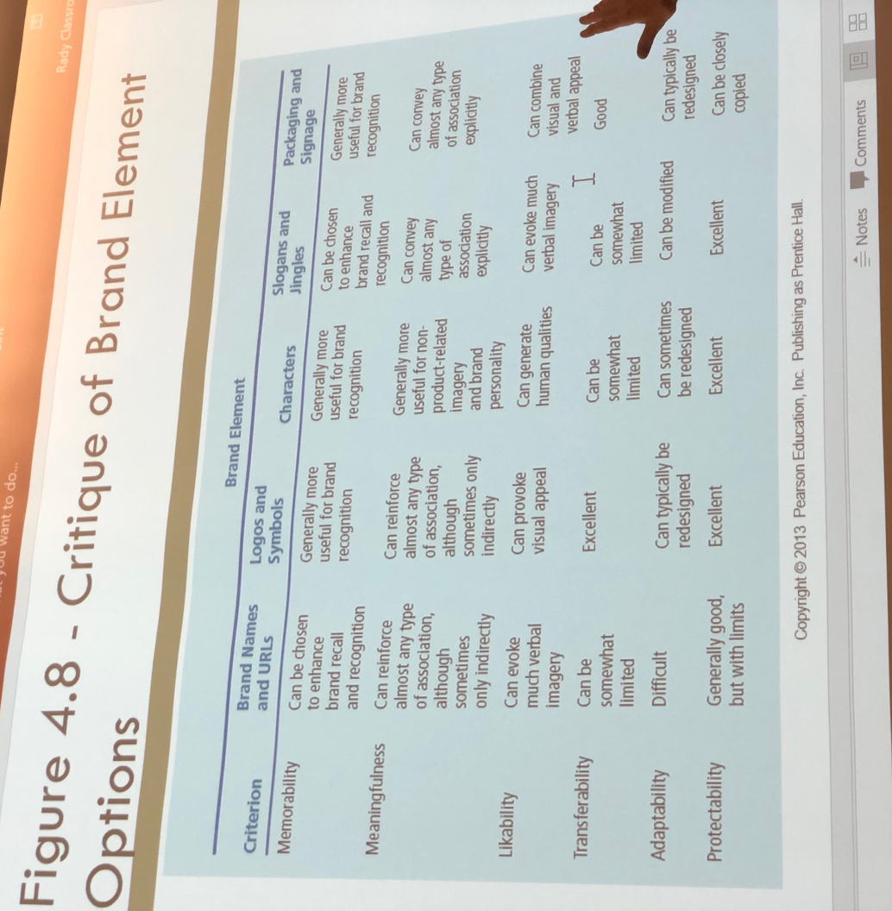
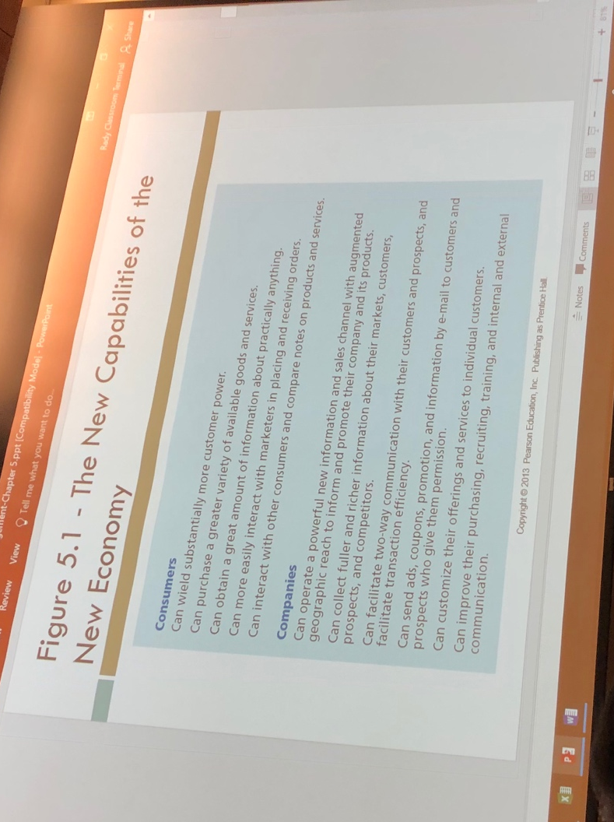
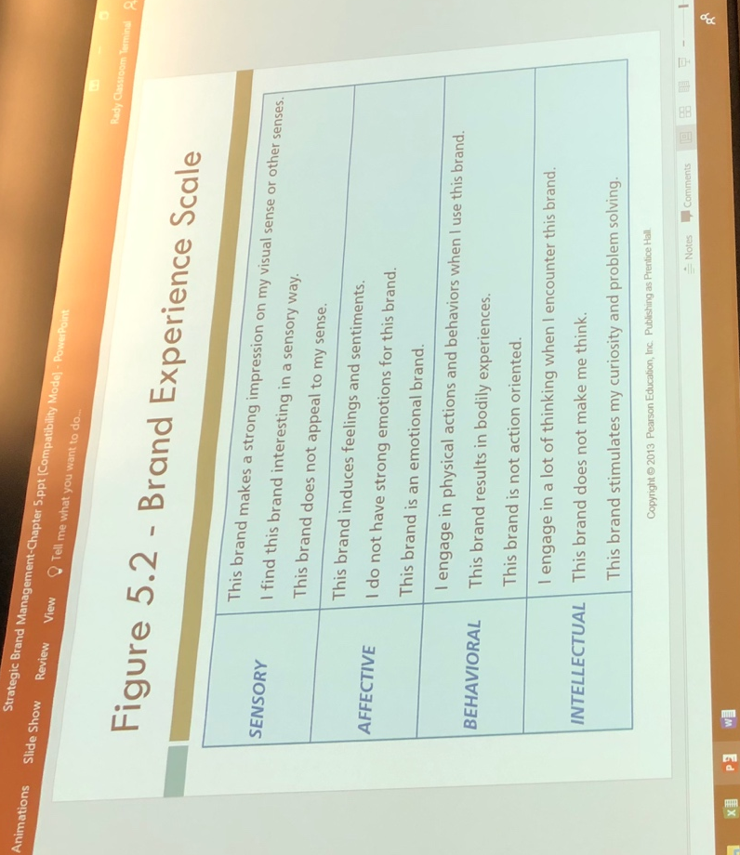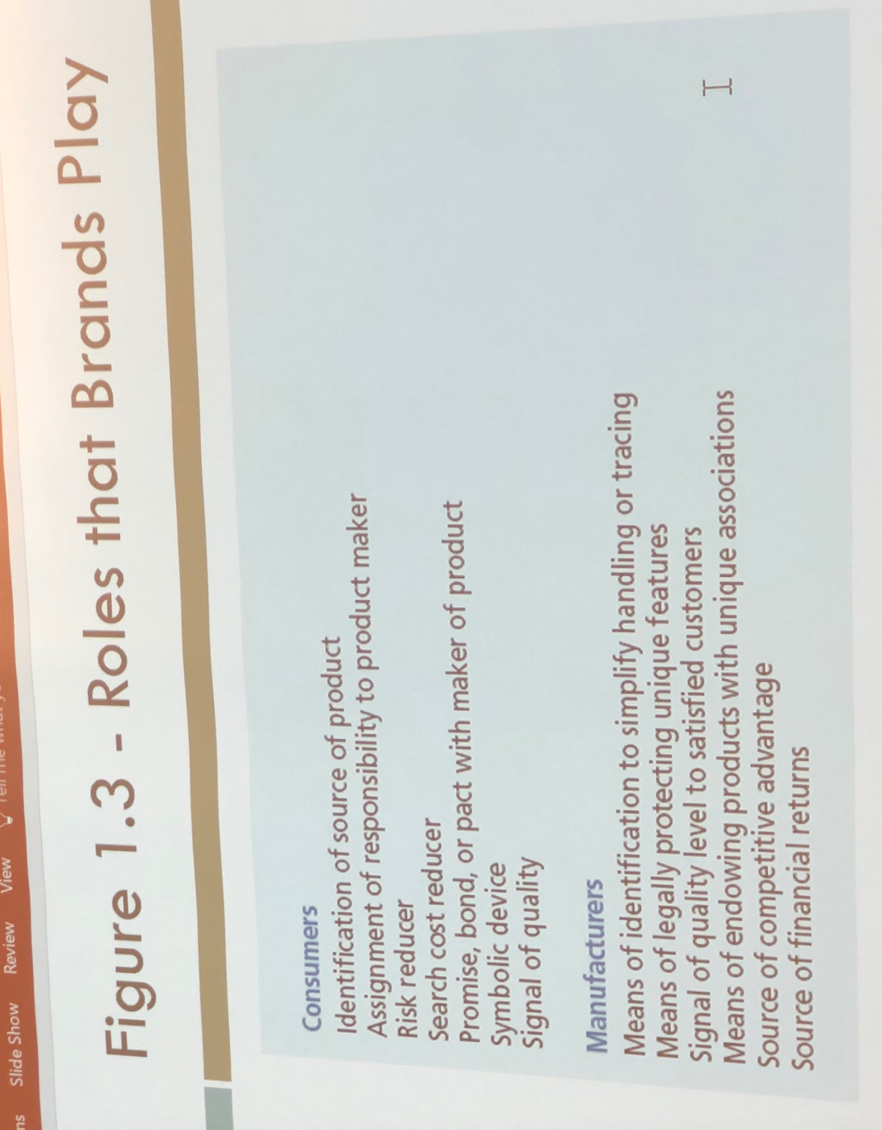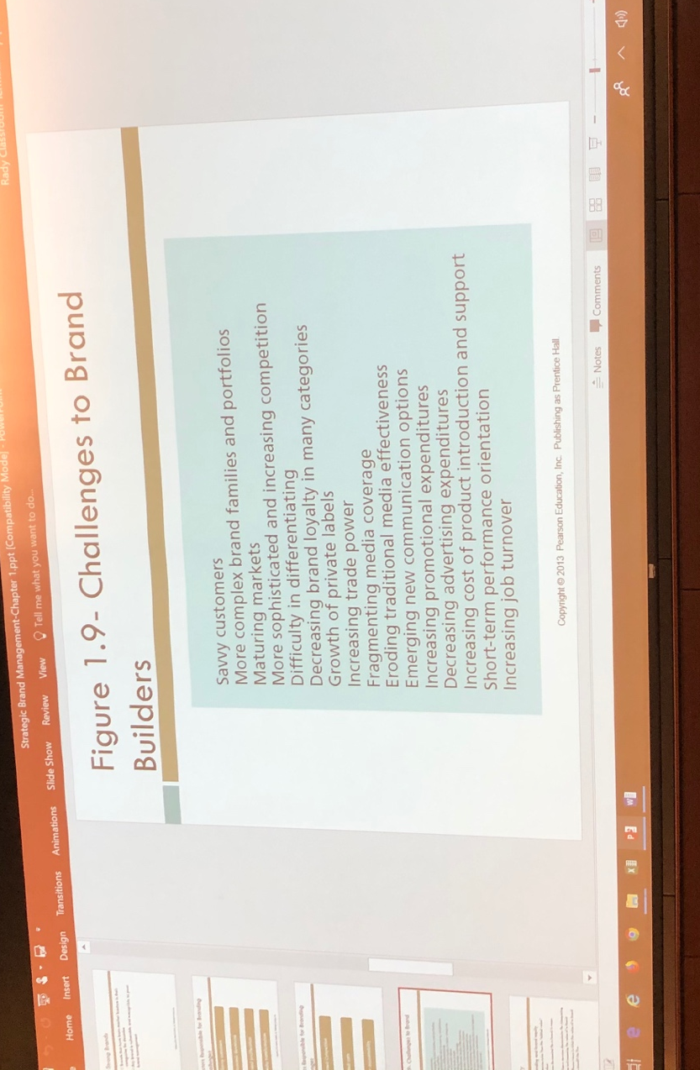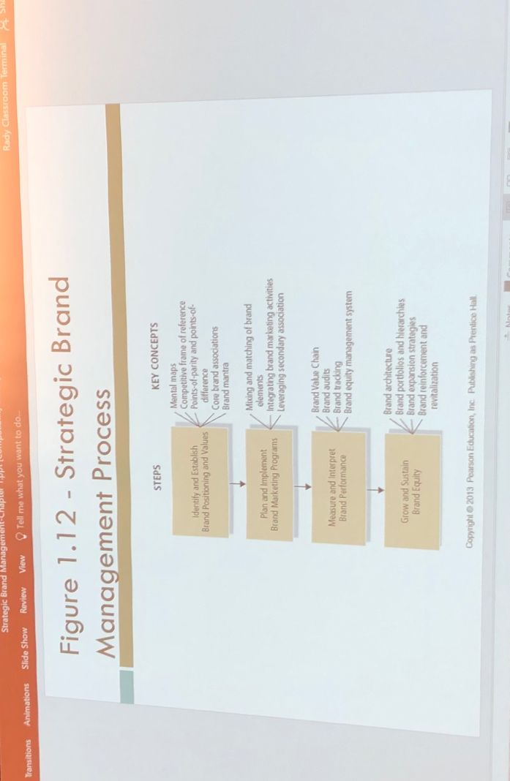
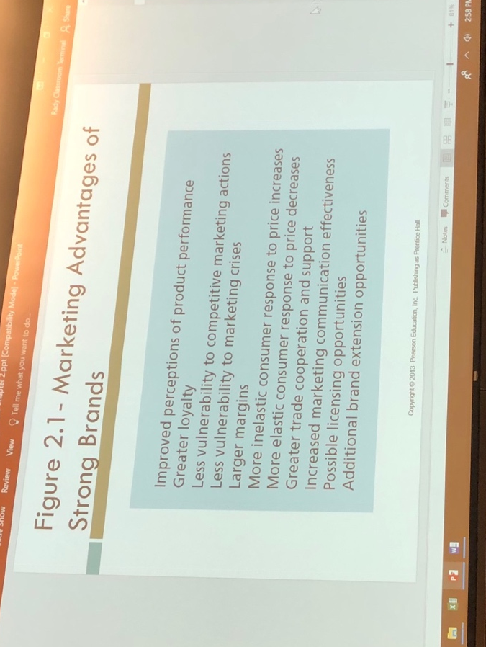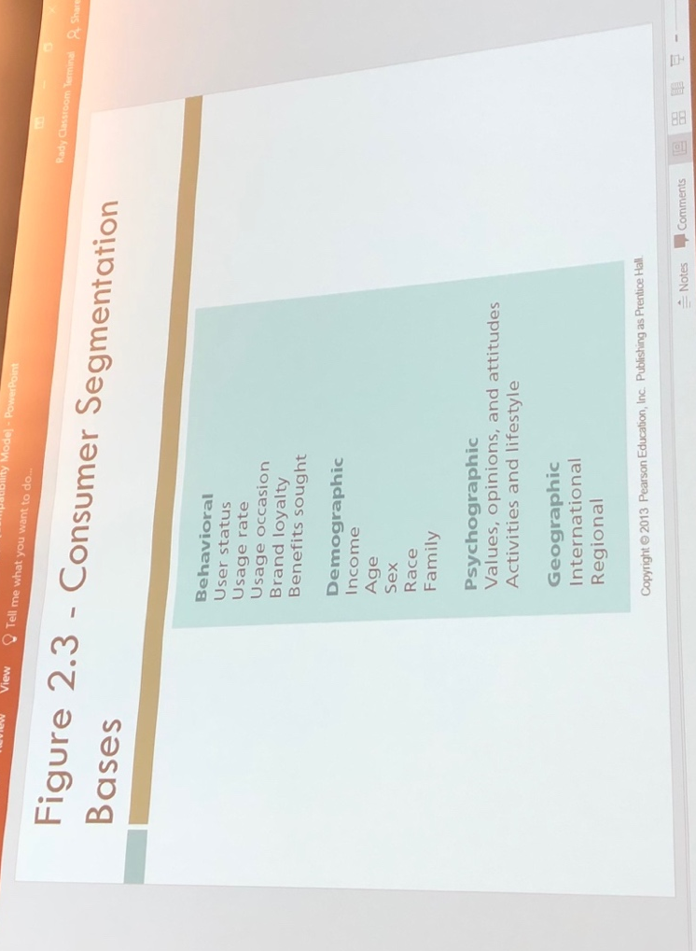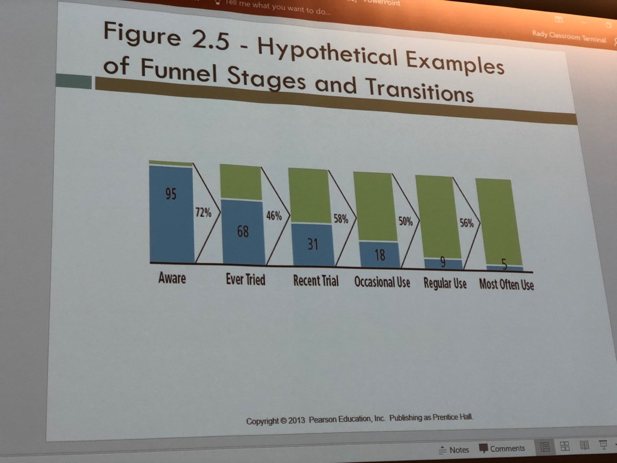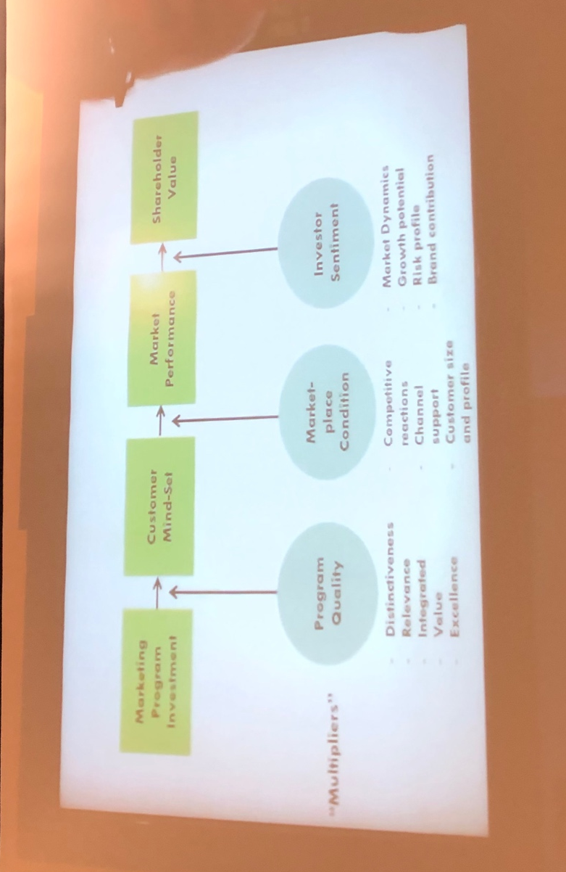
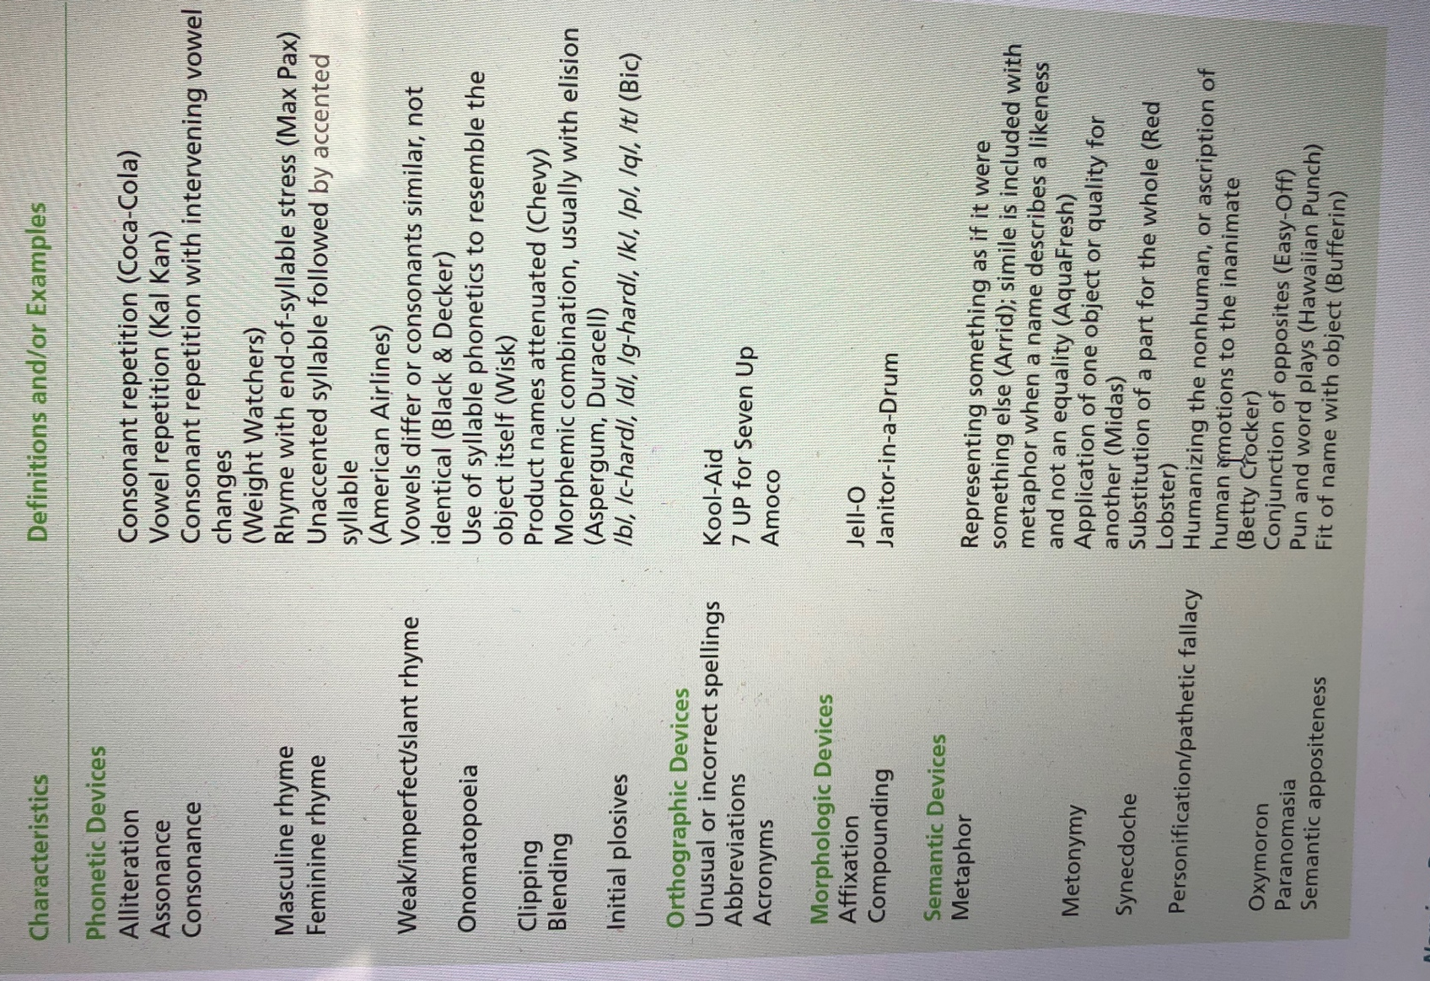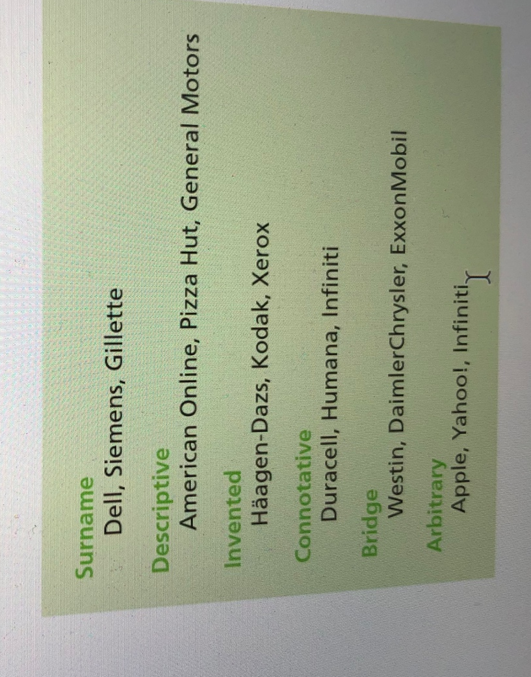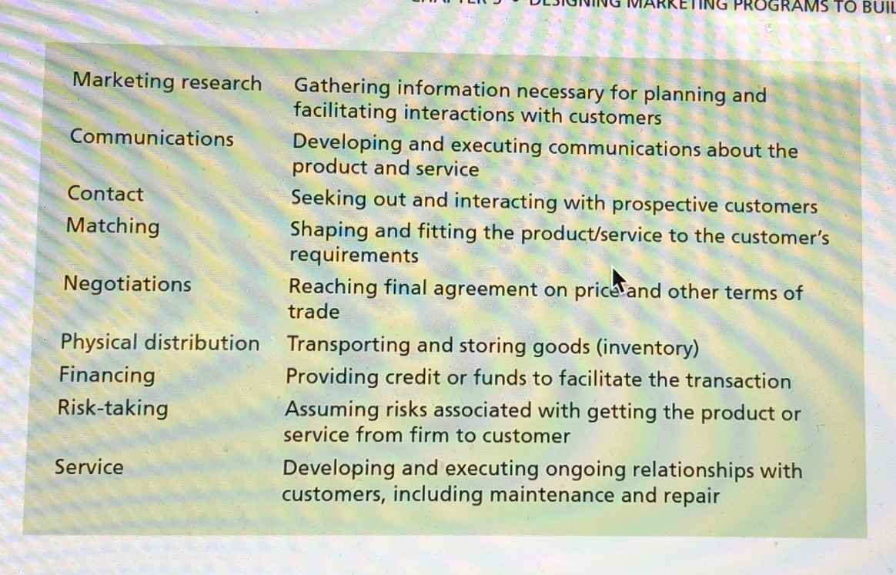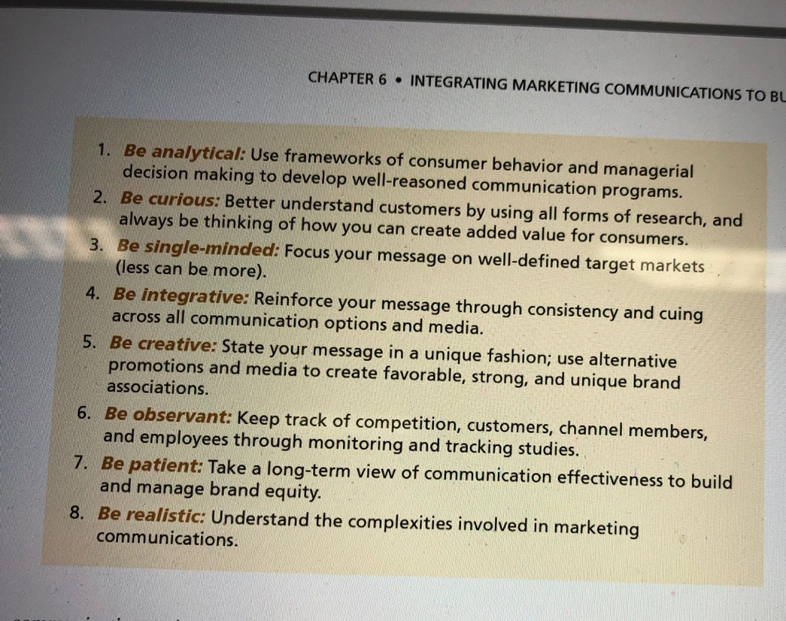

1
. Identity
Who are you?
Intense,
active loyalty
Positive,
accessible reactions
Points-of-parity
and -difference
Deep, broad
brand awareness
4
. Relationships
What about you and me?
Branding Objective at
Each Stage
Stages of Brand
Development
3
. Response
What about you?
. Meaning
2
What are you?
Resonance
Feelings
Judgments
Performance
Imagery
Salience
Resonance
Loyalty
Attachment
Community
Engagement
Judgments
Quality
Credibility
Consideration
Superiority
Feelings
Warmth
Fun
Excitement
Security
Social Approval
Self-Respect
Performance
Primary Characteristics and
Secondary Features
Product Reliability,
Durability, and Serviceability
Service Effectiveness,
Efficiency, and Empathy
Style and Design
Price
Imagery
User Profiles
Purchase and Usage
Situations
Personality and
Values
History, Heritage,
and Experiences
Salience
Category Identification
Needs Satisfied

